There are two things to update SurvCE and then the device Firmware. They can be done separately.

SurvCE:

1. SurvCE Version 5.05:       [Get](http://ashgps.com/cs/SurvCE/5.05/SurvCE_Install.exe) from the [www.carlsonsw.com](http://www.carlsonsw.com) website
2. After you do the SurvCE, copy both these files:  
     <http://x9gps.com/Tools/i80/Firmware/1.4.24/SurvCE_SurvStar/LSParse.dll>  
     <http://x9gps.com/Tools/i80/Firmware/1.4.24/SurvCE_SurvStar/LSParse.dll>  
   Into the ‘Program Files/SurvCE/SurvStar’ folder on the data collector. They will replace existing files.

SurvCE will now be updated on your data collector.

I80 Firmware:

                Download this file: <http://x9gps.com/Tools/i80/Firmware/1.4.24/update_i80_v1.4.24_b20161226.bin>

To a thumbdrive. Turn off the i80, install two fully charged batteries, put the thumbdrive in the OTG adapter cable, put the cable in the USB connector on the bottom of the i80. Turn on the i80. After a minute, the i80 will ask to confirm the firmware update, click on the YES button.

After a few minutes, the receiver will reboot. Click on NO when it asks if you want to update, now the receiver will begin a ‘CHECKING’ sequence. Wait for it to finish.

I believe that your radio channel settings will be overwritten with default values. You will have to update them.

Here is a link to the ‘Standard’ USA frequency list:

<http://x9gps.com/Tools/i80/Firmware/1.4.24/USA_Standard_2017.cfg>

download it to your laptop.

Connect your laptop to the i80 head by Wi-Fi. The Wi-Fi access point name will be GNSS-xxxxxxx where xxxxxxx is the serial number of the head. The Wi-Fi password is ‘12345678’.

Now browse to this address:

<http://192.168.1.1/set_en.html>

You will see this screen:

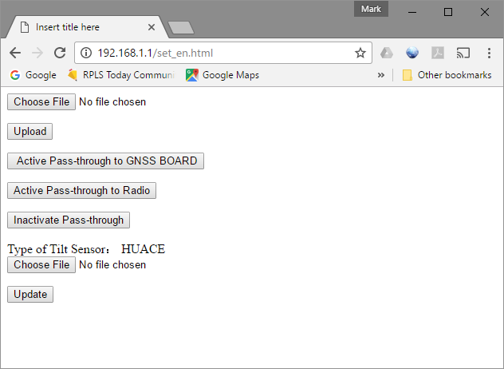

Click on the ‘Choose File’ at the top. Browse for .cfg file (downloaded above).

Now click ‘Upload’.

Turn off the receiver, then turn it back on again.

Update your second receiver.

Rebond your data collector to the receivers  (base and rover) and then go outside and make sure that they work well.